1.How are inline and block elements different from each other?
Inline elments: 1) It wraps around the content and takes up only certain space in which contatined elements can reside.
2) It doesn’t breaks and goes to next line
3) For example span, a, img tags are some example
Block elements: 1)It takes up full width of the page
2) it breaks to next line
3) For example, div, h1 etc
Script:
<!DOCTYPE html>
<html>
<head>
<link rel="stylesheet" href="form.css">
<meta charset="UTF-8">
<meta name="keywords" content="Java, Javascript">
<meta name="description" content=" This my details for google">
<title>To THE NEW</title>
<style>
div,span{
background-color:red;
height:20px;
}
</style>
</head>
<body>
<div>THis is div</div>
<span>THis is span</span>

</body>
</html>

Output:
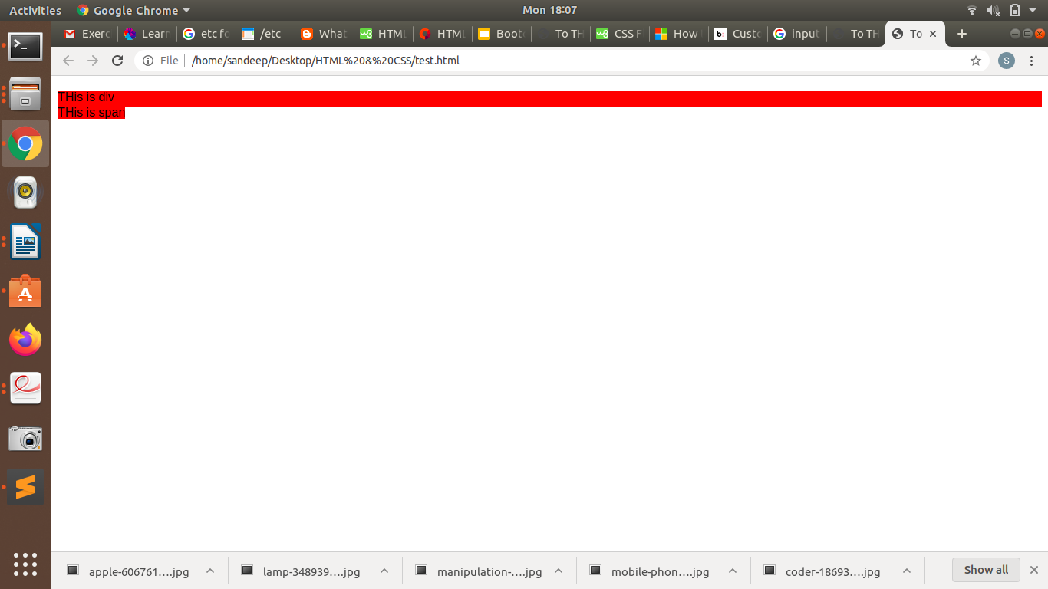

2.Explain the difference between visibility:hidden and display:none
Visibility hidden: It just hides the element but not the space.
Script:
<!DOCTYPE html>
<html>
<head>
<link rel="stylesheet" href="form.css">
<meta charset="UTF-8">
<meta name="keywords" content="Java, Javascript">
<meta name="description" content=" This my details for google">
<title>To THE NEW</title>
<style>
div{
width:20px;
visibility:hidden;
}
span{
background-color:red;
width:20px;

}
</style>
</head>
<body>
<div>THis is div</div>
<span>THis is span</span>

</body>
</html>
Output
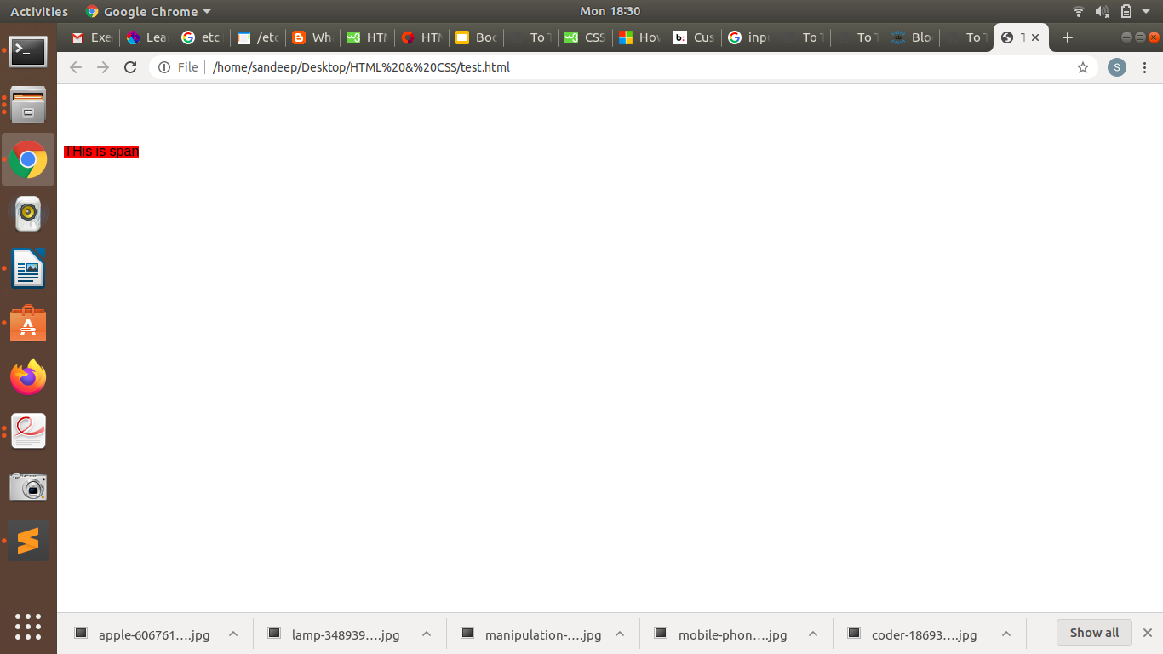
display:none : - It hides the element and also the space it has been taking. Like nothing was there.

Script:
<!DOCTYPE html>
<html>
<head>
<link rel="stylesheet" href="form.css">
<meta charset="UTF-8">
<meta name="keywords" content="Java, Javascript">
<meta name="description" content=" This my details for google">
<title>To THE NEW</title>
<style>
div{
width:20px;
display:none;
}
span{
background-color:red;
width:20px;

}
</style>
</head>
<body>
<div>THis is div</div>
<span>THis is span</span>

</body>
</html>

Output:
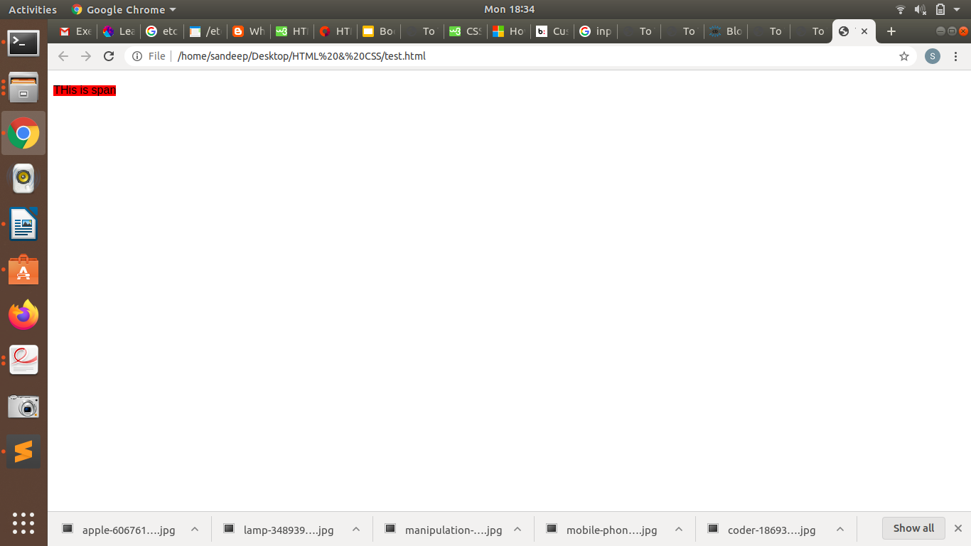

3. Explain the clear and float properties.
Float: it makes an element to float either from left or right. In other words, it makes an element to float, therefore, if I use three divs with different color. When I apply float left on second div, it starts floating to left and the third div takes the place of second div. And set underneath of second div.
Script:
<!DOCTYPE html>
<html>
<head>
<link rel="stylesheet" href="form.css">
<meta charset="UTF-8">
<meta name="keywords" content="Java, Javascript">
<meta name="description" content=" This my details for google">
<title>To THE NEW</title>
<style>
.one{
width:200px;
height:200px;
background-color: red;

}
.two{
width:200px;
height:200px;
background-color:green;
float:left;

}
.three{
width:200px;
height:200px;
background-color:yellow;

clear:left;
}

</style>
</head>
<body>
<div class="one"></div>
<div class="two"></div>
<div class="three"></div>

</body>
</html>

Output:
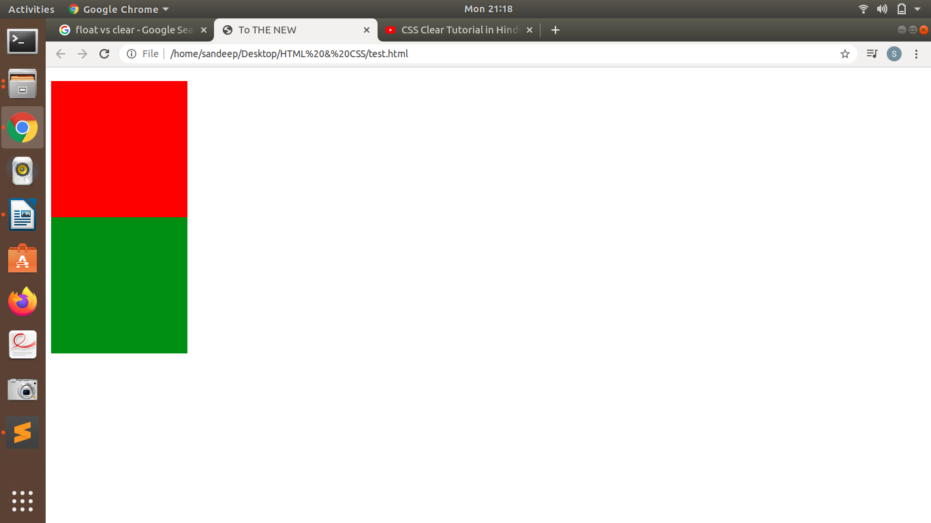
Clear: It clears the float effect. In above example, yellow div is underneath of green div. To get rid of it, we will use clear property.
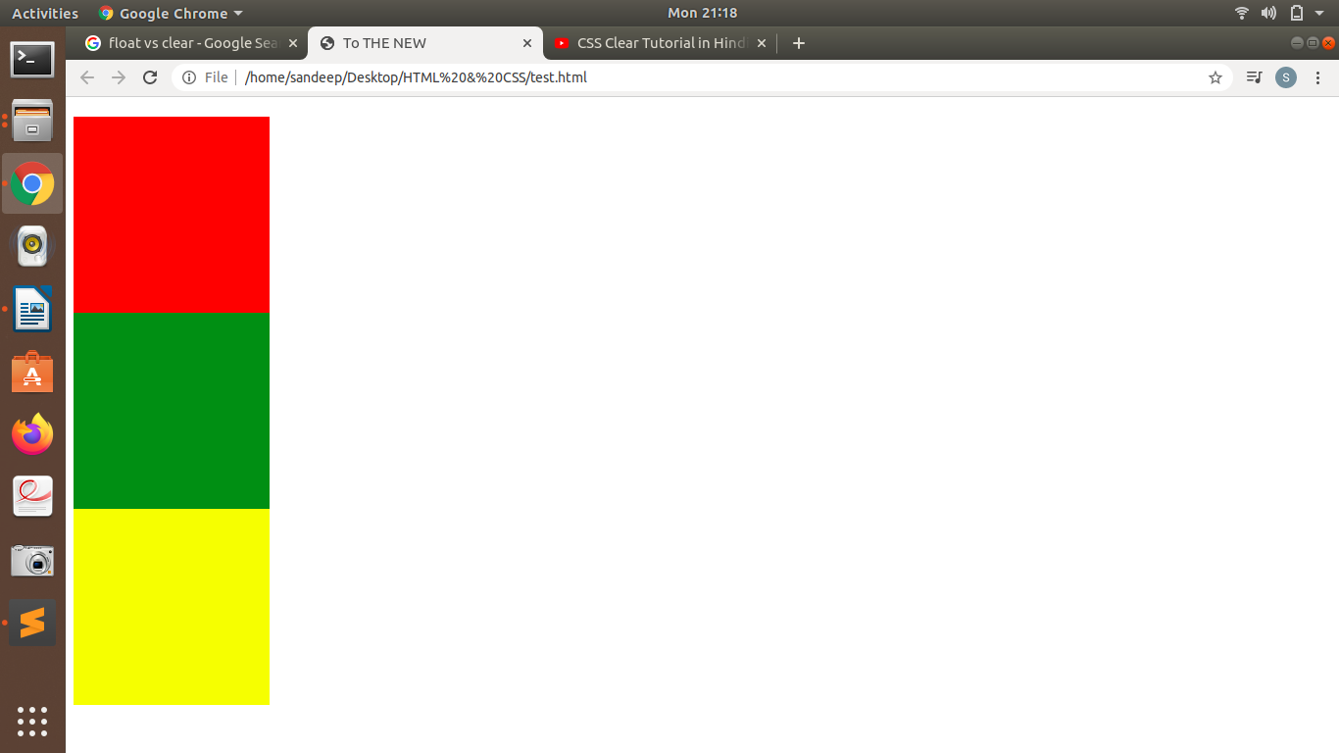

4. explain difference between absolute, relative,fixed and static.
Static: It is default positioning of an element which we see in HTML.
Fixed: It means the element having fixed positioning would always be sticked with the screen, even though we scroll through the page.
Relative:It gives the freedom to use top,bottom, left and right for positioning an element with this property.
Absolute: It uses nearest parent element to which it relative.
Script:
<!DOCTYPE html>
<html>
<head>
<link rel="stylesheet" href="form.css">
<meta charset="UTF-8">
<meta name="keywords" content="Java, Javascript">
<meta name="description" content=" This my details for google">
<title>To THE NEW</title>
<style>
.one{
width:100%;
height:200px;
background-color:red;
position:fixed;

}
.two{
width:200px;
height:200px;
background-color:green;

}
.three{
margin-top:100px;
width:900px;
height:500px;
background-color:yellow;
position:absolute;

}
.inner{
width:400px;
height:200px;
background-color:pink;
position:relative;

left:300px;
top:200px;
}

</style>
</head>
<body>
<div class="one"></div>
<div class="two"></div>
<div class="three">

<div class="inner">this is another element to work on</div>
</div>

</body>
</html>

Output:
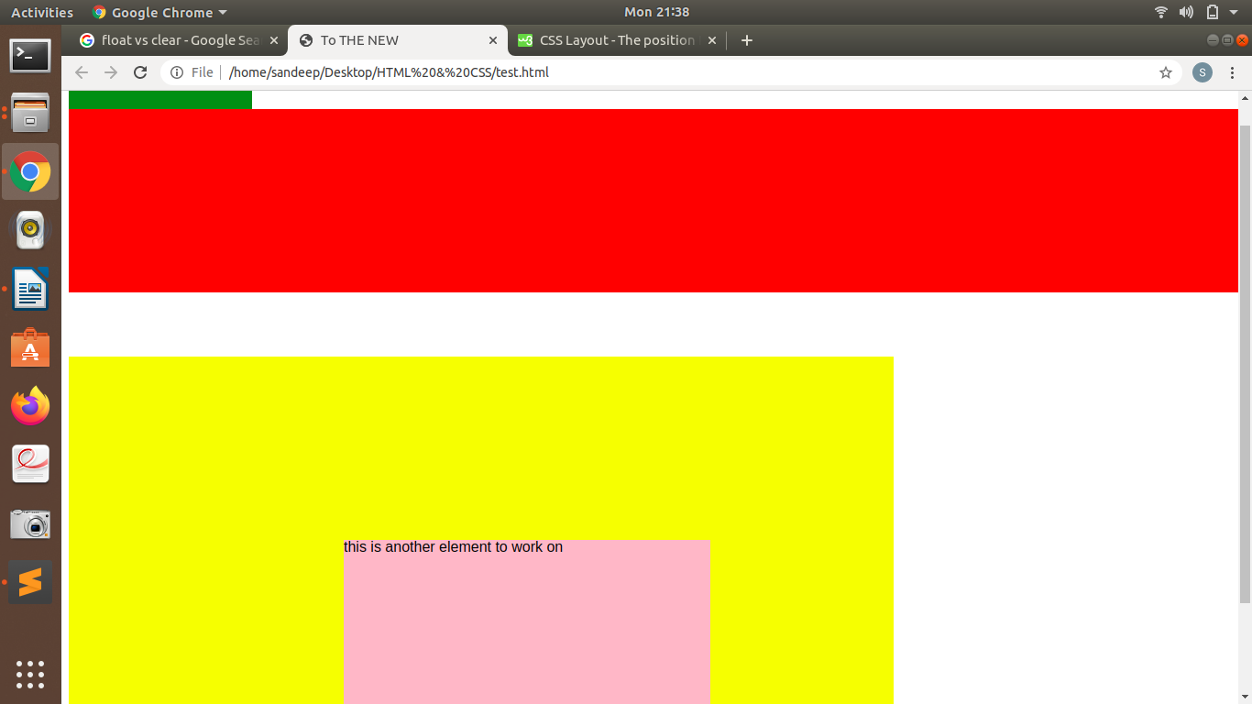
5. Write the HTML code to create a table in which there are 4 columns( ID , Employee Name, Designation, Department) and at least 6 rows. Also do some styling to it.
Script:
<!DOCTYPE html>
<html>
<head>
<link rel="stylesheet" href="form.css">
<meta charset="UTF-8">
<meta name="keywords" content="Java, Javascript">
<meta name="description" content=" This my details for google">
<title>To THE NEW</title>
<style>
table{
width:50%;
margin:auto;
border:1px solid grey;
}
tr:nth-child(even) {background-color: #f2f2f2;}

th{
background-color: pink;
color: white;
}

th, td {
text-align:center;
padding: 15px;

}

</style>
</head>
<body>
<table >
<tbody>
<tr>
<th>ID</th>
<th>Employee Name</th>
<th>Designation</th>
<th>Department</th>
</tr>
<tr>
<td>1</td>
<td>Sandeep</td>
<td>Java Developer</td>
<td>IT</td>
</tr>
<tr>
<td>2</td>
<td>Shreya</td>
<td>Java Developer</td>
<td>IT</td>
</tr>
<tr>
<td>3</td>
<td>Pradeep</td>
<td>iOS Developer</td>
<td>IT</td>
</tr>
<tr>
<td>4</td>
<td>Sammak</td>
<td>Web Developer</td>
<td>IT</td>
</tr>
<tr>
<td>5</td>
<td>Shakher</td>
<td>Java Developer</td>
<td>IT</td>
</tr>
</tbody>
</table>
</body>
</html>

Output:
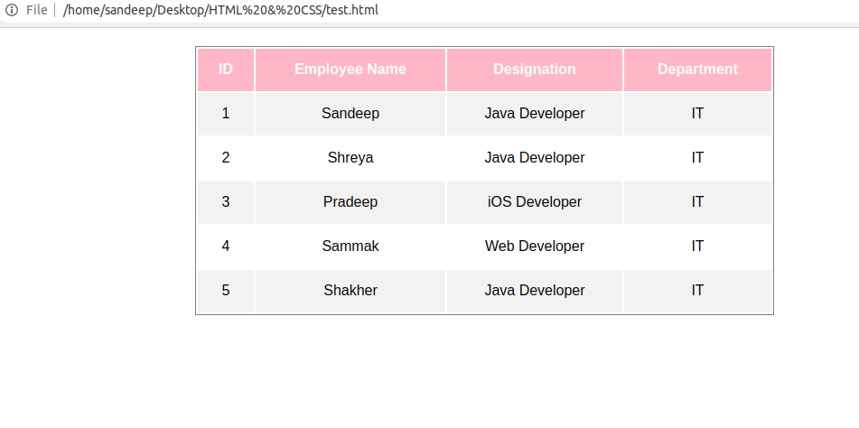

6. Why do we use meta tags?
The <meta> tag provides metadata about the HTML page to the search engines and it can easily understand by these search engines. It is defined in head tag and most of the elements in head tags are not visible and used by seach engines to rank the site.
Meta elements are typically used to specify page description, keywords, author of the document, last modified, and other metadata.
<meta charset="UTF-8">
<meta name="keywords" content="Java, Javascript">
<meta name="description" content=" This my details for google">

7. Explain box model.
The CSS box model is essentially a box that wraps around every HTML element. It consists of: margins, borders, padding, and the actual content. The image below illustrates the box model:
Content - The content of the box, where text and other data appear
Padding - Clears an area around the content. The padding is transparent
Border - A border that goes around the padding and content
Margin - Clears an area outside the border. The margin is transparent

Script:

<head>
<link rel="stylesheet" href="form.css">
<meta charset="UTF-8">
<meta name="keywords" content="Java, Javascript">
<meta name="description" content=" This my details for google">
<title>To THE NEW</title>
<style>
.container{
position:absolute;
width:600px;
height:600px;

background-color:red;
}
.one{width:200px;
position:relative;
height:200px;
padding:50px;
margin:40px;
border:10px solid black;
background-color:green;

}
</style>
</head>
<body>
<div class="container">

<div class="one"></div>
</div>
</body>
</html>
Output:
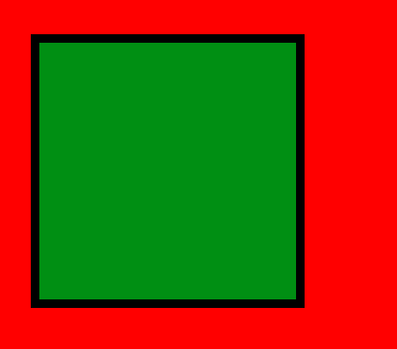

8. What are the different types of CSS Selectors?
ID: This selector should be unique. It is used to target one or more elements together to apply css. It reperesented by #.
Class: This selector can be used multiple times and frequently. It is used to target one or more elements together to apply css. It is represented by ‘.’
Universal selector: It means select all and its effects can be seen throughout the web page. It is represented by *
Element selector: It targets html tags and formmating are made accordingly. For example, img,p etc.
Group Selector: When we have to make same changes on multiple places, then we simply put them togehter by using comma.
Script:
<!DOCTYPE html>
<html>
<head>
<link rel="stylesheet" href="form.css">
<meta charset="UTF-8">
<meta name="keywords" content="Java, Javascript">
<meta name="description" content=" This my details for google">
<title>To THE NEW</title>
<style>
*{

font-family: Arial;
}
#header{
width:100%;
height:30px;
background-color:pink;
}
.container{
margin-top:20px;
background-color:yellow;
}
p{
text-decoration:underline;
}
.container, p{
color:blue;
}
</style>
</head>
<body>
<div id="header"></div>
<div class="container">
<p>This is container class </p>
</div>

<p>This is text in paragraph tag</p>

</body>
</html>

Output:
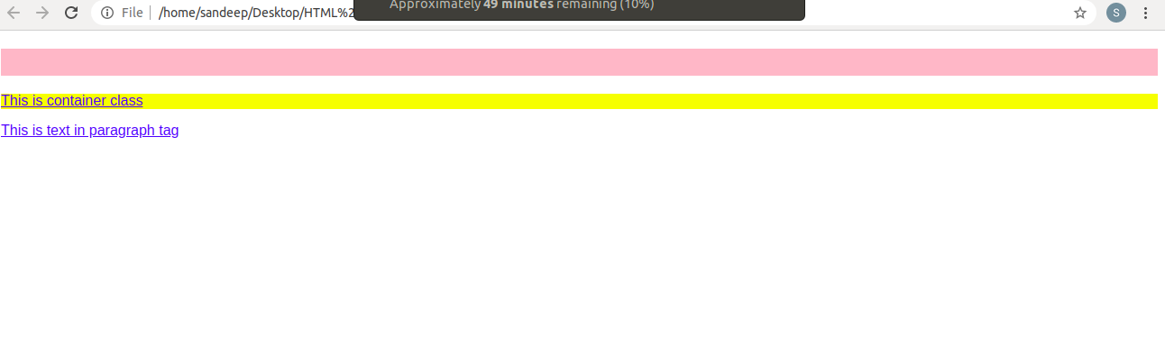

9. Define Doctype.
doctype is an information which tells the web browser about the markup language in which the current page is written. The Doctype is not an element or tag, it lets the browser know about the version of or standard of HTML or any other markup language that is being used in the document.
<!DOCTYPE html>

10. Explain 5 HTML5 semantic tags.
Section: It is used to represent a part of webpage consisting articles.
Article: As name suggests, it encloses stories or text and usually comes under the Section tag.
Hgroup: It represents a group of headers.
Nav: it represents navigation bars consisting different tabs
Footer: As name suggests, it is the bottom part of a webpage consisting copywright information and navigation information

Script:
<!DOCTYPE html>
<html>
<head>
<link rel="stylesheet" href="form.css">
<meta charset="UTF-8">
<meta name="keywords" content="Java, Javascript">
<meta name="description" content=" This my details for google">
<title>To THE NEW</title>
</head>
<nav>
<ul>
<li><a href="/home">Home</a></li>
<li><a href="/about">About</a></li>
<li><a href="/contact">Contact us</a></li>
</ul>
</nav>
<hgroup>
<h1>Heading 1</h1>
<h2>Subheading 1</h2>
<h2>Subheading 2</h2>
</hgroup>

<section>
<p>Top Stories</p>
<section>
<p>News</p>
<article>Story 1</article>
<article>Story 2</article>
<article>Story 3</article>
</section>

<footer></footer>

</body>
</html>

11. Create HTML for web-page.jpg (check resources, highest weightage for answers)
Index.html
<!DOCTYPE html>
<html>
<head>
<link rel="stylesheet" href="style.css">
<meta charset="UTF-8">
<meta name="keywords" content="Java, Javascript">
<meta name="description" content=" This my details for google">
<title>To THE NEW</title>
</head>
<body>
<div id="head">

<h1>TO THE NEW</h1>
<div id="nav">
<ul>
<li><a href="#">Home</a></li>
<li><a href="#">Work</a></li>
<li><a href="#">About</a></li>
<li><a href="#">Contact</a></li>
</ul>

</div>

<div id="body">

<div id="article">

<img src="main.jpg" alt="main" width="960" height="360">
</div>

<div class="para"> <p> THIS IS RANDOM TEXT TO TEST THE FORMATTING AS PER THE GIVEN EXERCISE. I HAPPY, IT IS GOING WELL AS IT SHOULD</p><p>
I AM JUST WRITING FOR NO REASON AS I HAVE TO FILL ATLEAST TWO LINES. LET'S LOOK AT THE BROWSER!</p></div>
</p>

<div class="third_block">
<h4>LATEST FROM GALLARY</h4>
<hr/>

<div class="gallary">
<ul class="trying">
<li><div><img src="img1.jpg" alt="main" width="215" height="315">
<p>Img1</p>
</div>
</li>
<li><div><img src="img2.jpg" alt="main" width="215" height="315"><p>Img2</p></div></li>
<li><div><img src="img3.jpg" alt="main" width="215" height="315"><p>Img3</p></div></li>
<li><div><img src="img4.jpg" alt="main" width="215" height="315"><p>Img4</p></div></li>
</ul>
</div>
</div>

<div class="footer">
<span class="left_part">&copy; all right reserved. 2018-20</span>
<span class="right_part">By sandeep verma</span>
</div>

</div>

<div>
</body>

</html>

Style.css

body{

background-color:#696969;

}
#head{
margin:auto;
background-color:grey;
width:90%;
height:150px;
background-color:#808080;
}

#nav{
margin:auto;
width:95%;
margin-top:45px;
padding:5px 2px 5px 2px;
background-color:#696969;
}
#nav ul{
background-color:#696969;

}
#nav ul li a{
text-decoration:none;
color:white;

}

#nav ul li{

display:inline;
margin-left:10px;
color:white;
background-color:#696969;

}

/*BODY*/
#body{
background-color:white;
height:1000px;
margin-top:30px;

}
#article{
width:960px;
height:360px;
color:white;
margin:auto;
background-color:#808080;
border:10px solid white;

}

#body .para{
margin-top:50px;
margin-left:90px;
width:960px;
padding:5px 2px 5px 2px;
background-color:#d3d3d3;

}

/*Gallary*/
.trying{
display:flex;
justify-content:space-around;
}
.third_block{

width:960px;
height:360px;
margin:auto;

}
.gallary ul li div p{
background-color:grey;
margin-top:-5px;
text-align: center;
padding:2px 1px 2px 1px;

}

.footer{
margin-top:80px;
height:60px;
background-color:black;
color:#696969;
}
.footer .right_part{
margin-top:10px;
display:inline-block;
float:right;
margin-right:5px;

}
.left_part{
margin-top:10px;
display:inline-block;
margin-left:5px;

}

Output:
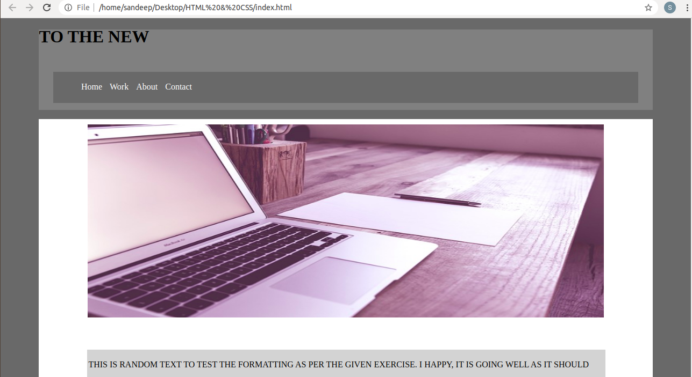
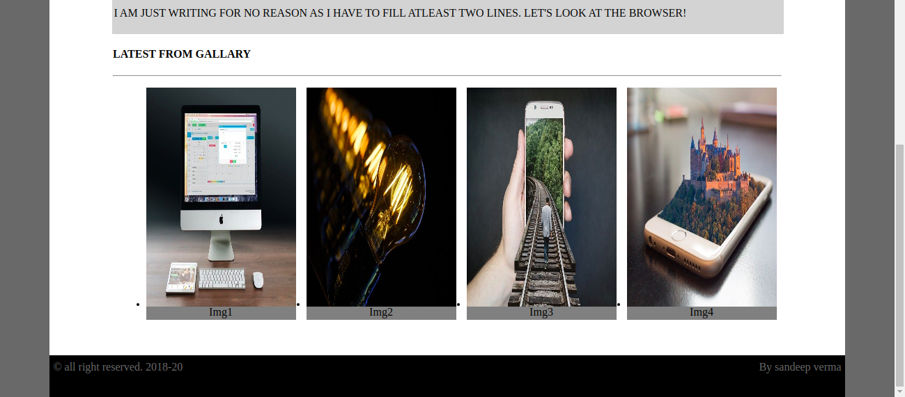

12. Create HTML for form.png (check resources, highest weightage for answers)
Note: 50% of marks are for last 2 exercises of creating html pages
form.html
<!DOCTYPE html>
<html>
<head>
<link rel="stylesheet" href="form.css">
<meta charset="UTF-8">
<meta name="keywords" content="Java, Javascript">
<meta name="description" content=" This my details for google">
<title>To THE NEW</title>
</head>
<body>
<div id="head">

<span>TO THE NEW</span>
<div id="nav">
<ul>
<li>Home</li>
<li> Quick Help</li>
</ul>
</div>
<h3>Bug Report</h3>
<form class="flex_work"method="post" action="#">
<label>
Title*:
</label>

<input type="text" required>

<label>
Description:
</label>
<textarea name="message" rows="5" cols="20" required></textarea>
<label>
Operating System:
</label>

<select name="Operating System">
<option class="select" value="Windows XP">Windows XP</option>
<option class="select" value="Windows 7">Windows 7</option>
<option class="select" value="Windows 10">Windows 10</option>
<option class="select" value="Windows Vista">Windows Vista</option>
</select>

<label>
Product:
</label>

<select name="Product">
<option value="Windows XP">PUBG</option>
<option value="Windows 7">ROS</option>
<option value="Windows 10">COD</option>
</select>

<label>
Version:
</label>
<input type="number" name="version" min="1" max="2">
<label>
License:
</label>
<fieldset>
<input type="radio" name="license" value="Free"><label>Free </label>
<input type="radio" name="license" value="Business"><label>Business </label>
</fieldset>

<label>
Severity:
</label>
<select name="Severity">
<option class="select" value="Critical">Critical</option>
<option class="select" value="Critical">Possible</option>
</select>

<label>
Attachments:
</label>
<input type="file" name="documents" accept="file/*">

<div class="divide">
<input type="Submit" name="Send" value="Send">
</div>
</form>
<br/>
<br/>

</body>
</html>

form.css

*{
font-family:sans-serif;
}
body{
margin-top:20px;
}
#head{
color:#06A061;
border-bottom:0.5px solid #E7E4E4;
height:50px;
}

#head span{
font-size:20px;
color:#06A061;

}

#nav{
margin-top:-30px;
}

#nav ul li{

display:inline;
margin-left:20px;
float:right;
}
.flex_work{
display:flex;
flex-direction:column;
}
h3{color:white;

width:30%;
padding: 15px 2.5px 15px 2.5px;
margin:auto;
margin-top:80px;
background-color: #E7E4E4;
}
form{
border:2px solid #E7E4E4;
color:black;
margin:auto;

width:30%;

}
form input,select,textarea{
margin-top:20px;
padding:5px 2px 5px 2px;
width:90%;
margin:auto;
border-radius:5px;
border:1px solid #E7E4E4;
}

form label{
font-size:14px;
margin-left:20px;
margin-top:15px;
}

input[type="radio"]{
display:inline-block;
margin-right:20px;
margin-left:-20px;
width:70px;
}
fieldset{
border:none;
}

.select,select{
background-color:#06A061;
color:white;

border:none;
font-weight:500;
}

input[type="submit"]
{
background-color:#06A061;
color:white;
width:60px;
float:right;
margin-top:25px;
}

.divide{
margin-top:5px;
height:50px;
border-radius:5px;
background-color:#E7E4E4;

}

Output:
